Howden Equestrian Centre

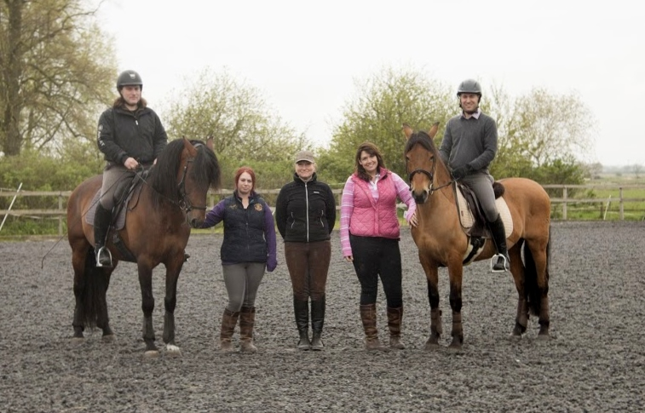
Terms and conditions.
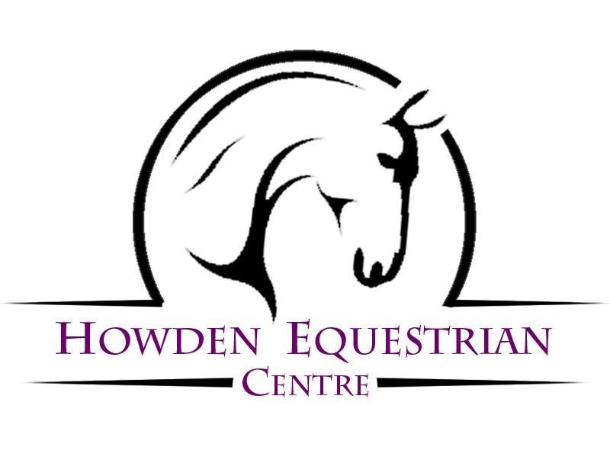

Terms and conditions
- ALL Clients:
  - Must have completed a Rider Registration Form before riding a horse. This will be countersigned after the lesson by an instructor.
  - Must resubmit their Rider Registration Form if their details change. (the responsibility falls to the Parent/Guardian if the child is under 18).
  - We reserve the right to refuse you to ride a particular horse/pony if we feel that the safety of the rider or horse is in question.
  - You reserve the right to change to another horse/ pony, providing one is available, and it is practical and safe to do so.
  - You also have the right to request another Instructor subject to availability.
- Punctuality and Arrival Times:
  - Please arrive 5 minutes before the start of the lesson to allow time for hat fitting.
  - If you are late, we unfortunately cannot make that time up as other clients will be waiting for their lessons to start on time. You will not be refunded for missed lessons.
  - If we are running late for whatever reason we will make up your lesson time
- New Clients:
  - Are required to attend an assessment lesson before being allowed join an existing group. This allows us to ascertain your riding level.
  - All Clients Rules Apply.
- Payments:
  - If you fail to turn up, you will be required to pay in full.
- Cancellations:
  - 48 hours’ notice MUST be given for any cancellations.
  - If less than 48 hours’ notice is given, the lesson will be charged for at the full rate. This includes all cancellations, regardless of reason, and does include illness.
- Instructors:
  - Instructors reserve the right to refuse to teach a client for any reason.
- Bad Weather or Conditions:
  - Activities might be cancelled in extreme weather.
  - You should call us on 07562393494 before you leave for the centre if the weather is in doubt. If we have not contacted you, please do not assume the lesson is cancelled, often it is not as bad here as it might be elsewhere. We will always be contacted in the case of extreme weather cancellations.
  - We reserve the right to cancel riding because of bad weather at any time.
  - Lessons will run as normal unless you are contacted.
- Safety Equipment and Riding Wear:
  - P.P.E (Personal Protective Equipment): Every time you handle a horse you are required to wear the appropriate Personal Protective Equipment.
  - Riding Helmets:
    - Hats (all types): Should be up to current BHS riding standards
    - Must be worn and fastened at all times while riding a horse.
    - Must be worn and fastened at all times while handling or a horse.
    - We strongly advise all customers to purchase their own helmet as soon as possible.
      - We recommend against purchasing second hand riding helmets in case they have been damaged.
      - We reserve the right to refuse you lessons if hat is not up to standard
    - We reserve the right to charge customers for helmet hire after 1 lessons have passed.
      - Cost per Session is £5.
  - Body Protectors:
  - We do not provide body protectors, nor can we fit one, we are not qualified fitters
  - Use of body Protectors is a choice which is down to parent’s discretion.
  - Riding Footwear:
    - Clients must wear appropriate footwear while riding.
    - Allowed Footwear:
      - Jodphur Boots
      - Riding Boots
      - Wellies with a small heel
      - Most boots with a small heel
    - Disallowed Footwear:
      - Trainers
      - High Heels
      - Sandals
      - Flipflops
      - We reserve the right to refuse footwear we deem unsafe.
    - We recommend toe protection whenever handling a horse.
  - Jewelry:
    - You should not wear Jewelry of any kind, anything you wear you do so at your own risk.
    - It's the parents responsibility to check their child isn't wearing Jewelry.
- Extra Visitors and/or Friends of the Family:
  - Children must be supervised at all times by a legally responsible person.
  - Parents are advised not to leave your children unattended at any time during their stay
  - If spectating, please remain as quiet as possible, and in full view of the horses/ponies & Instructor at all times.
  - Whilst spectating, the Instructor reserves the right to ask you to leave the arena area if they feel the safety of the rider or horse/pony is in question.
  - Young Children: Must be supervised at all times by a responsible person and remain seated and quiet whilst lessons are in progress and not to run around. No climbing or sitting on fences is allowed.
  - No running / shouting / jumping etc on the yard at any point. Please do not run past the main arena.
  - No climbing on fences or standing on arena gates.
- Movement of Horses & ponies and Farm Equipment around the yard and surrounding areas is unavoidable and we ask you to give way to them at all times.
- Out of Bounds:
  - There are No Entry Type signs and safety notices posted around the facility, you must acknowledge and obey them, ignoring them is at your own risk.
- Warning Signs: We have many different warning signs on the yard, they are there for a reason, you must obey them. We reserve the right to ask you to leave at any time if we think you are a danger to yourself or others.
- Smoking Policy: We have a Strict No Smoking Policy anywhere on the premises, if you are caught you will be asked to leave.
- Pets: We don't allow any clients to bring their own pets onto the grounds/premises.
  - Guide Dogs are allowed by prior arrangement.
- Horses/Ponies: All animals are unpredictable, Do Not Feed the Horses & Ponies at any time. Don't enter any field, box or make contact with a Horse or Pony at any time, without prior authorisation from a member of staff.
- Cars, Bicycles: We can't be held responsible for any damage to your transportation while on the premises/grounds. All vehicles are parked at your own risk.
- Personal Property: We can't be held responsible for Damage, Theft or Loss of your personal property while it's on the premises.
- OTHER:
  - Parking is not permitted outside the gateway / blocking neighboring gateways.
  - The drive is not a footpath and walkers are advised to take extreme care due to the uneven surface.
  - Maximum Speed on the premises / private driveway is 10 mph.
- RIDING IS A RISK SPORT - Your choice to ride is voluntary. We take all reasonable care to provide suitable and safe horses and ponies for all our clients. All animals can be Unpredictable. We strongly advise you to take out full personal accident cover.
- PLEASE NOTE: Howden Equestrian Centre, Owners & Staff cannot be held responsible for any accident, injury or loss to any persons or their property whilst on these premises or whilst out hacking.
- Agreement of Terms: If you do not agree with any of Terms and Conditions, then you do not have permission to enter the premises and any bookings are null and void. Our no Cancellation Policy applies in this situation as well because our Terms and Conditions are available online and on request at any time. As such you have every opportunity to read them before booking any activity and a refund will not be available on failure to accept them.

